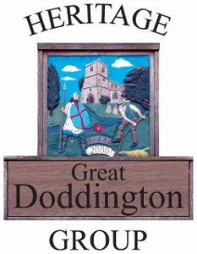

**As part of the Coronation celebrations and the Scarecrow weekend we will be displaying photographs and memorabilia of :-**

**1910 1937 1953 Coronations village celebrations**

**Platinum Jubilee Street Party 2022**

**Previous scarecrow displays**

**In The Memorial Hall on**

**SUNDAY 7th May 2023**

**10.30 - 4.30 p.m.**

